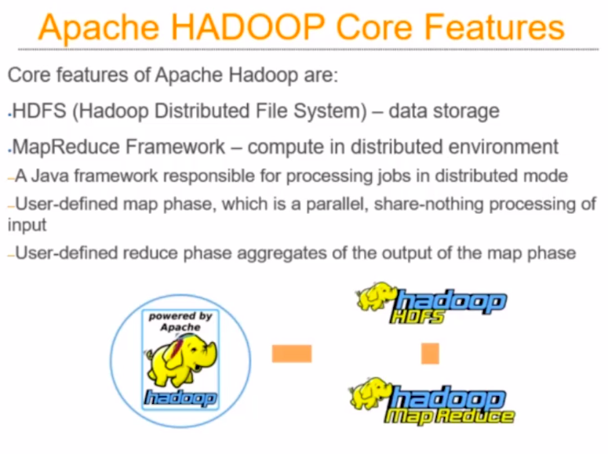
When you try to see Hadoop as a piece of software, there are two major components:
- HDFS (Hadoop Distributed File System)
- MapReduce Framework

HDFS:

HDFS is the common platform for storing and retrieving data.

MapReduce:

Once you have the data in HDFS, you need to process the data , for which you need parallel processing framework. And MapReduce is one such framework, Please note that MapReduce is not the only framework for doing the Parallel Processing. The idea of parallel processing is there from 1970s or 1960s, Hadoop is just one of the parallel processing framework which is use for solving a wide variety of problems.

NOTE: MapReduce is a framwork for Parallel Processing and Hadoop is a Platform for Parallel Processing.

MapReduce is completely written in Java.

